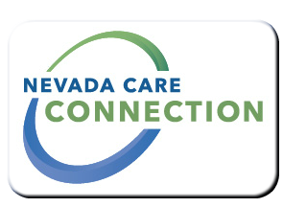
State of Nevada
Department of Health and Human Services
Aging and Disability Services Division
rt Division Here>

Consumer
FACT SHEET

Nevada Medicaid- Habilitation Services
Purpose
Home based Habilitation is Nevada’s program for individuals’ with a traumatic or acquired brain injury in a community based setting. Services are designed to help individuals retain and improve the self-help, socialization, and adaptive skills necessary to reside in a home and community based setting. Services are delivered on a regular schedule in a supportive living environment or a day treatment setting to help people to stay living in their homes and out of an institution or nursing home following successful completion of rehabilitation services.
Target Population
Adults 18 years and older

Eligibility
Must be eligible for Nevada Medicaid and must meet eligibility requirements based on an assessment and medical evaluation.
Services

- Behavioral health therapy services
- Nursing services for giving medications and medical treatments. Nurses may do assessments, plan care and provide direct supervision to meet a person’s medical needs.
- Restorative therapy and training in Activities of Daily Living like bathing and grooming. Social services and case management.
- Therapy services such as speech, occupational and physical therapy
Program Policies and Procedures
Policies and procedures are outlined in Medicaid Services Manual Chapter 2400.
http://dhcfp.nv.gov/Resources/AdminSupport/Manuals/MSM/C2400/Chapter2400
How to Apply
Visit http://www.nevadacareconnection.org to Connect with a Resource Center in your area.
For Information
Division of Health Care Financing and Policy (Nevada Medicaid)  Carson City | Las Vegas  1210 South Valley View Blvd. Suite 104, Las Vegas NV 89102
1100 East Williams Street, Carson City, NV 89701
(775) 684-3600
Website
Division of Health Care Policy and Financing- Nevada Medicaid | www.dhcfp.nv.gov

Last Updated: 6/10/16 CP

