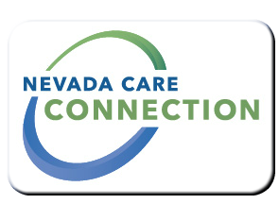
State of Nevada
Department of Health and Human Services
Division of Welfare and Supportive Services
rt Division Here>

Consumer
FACT SHEET

SUPPLEMENTAL NUTRITION ASSISTANCE PROGRAM (SNAP) FOOD STAMP PROGRAM
Purpose
The purpose of the SNAP (Food Stamp) Program is to raise the nutritional level among low-income households whose limited food purchasing power contributes to hunger and malnutrition among members of these households.
Target Population
Low income Nevadans in need of assistance with food.

Eligibility
Must meet income requirements; must be a legal U.S. citizen or resident; must be a resident of Nevada
For more eligibility information, visit: http://www.snap-step1.usda.gov/fns/
Services

- Food Stamps - SNAP benefits are spent like cash for food at stores that accept them; SNAP benefits are issued to an Electronic Benefits Transfer (EBT) account and may be accessed by using an EBT card. EBT cards are like an ATM Debit card.
Program Policies and Procedures
Program Policies and Procedures can be found online https://dwss.nv.gov/Home/Features/Eligibility-N-Payment-Info-Manual/
How to Apply
Applications can be completed and submitted online via https://dwss.nv.gov/TANF/Access_Nevada/ More information on how to apply can be found at https://dwss.nv.gov/TANF/Access_Nevada/
For Information
Sheri Gallucci, SNAP Program Specalist
1470 College Parkway, Carson City, Nevada, 89706
775-684-0608

Website
https://dwss.nv.gov/?SNAPApply.html

https://dwss.nv.gov/TANF/Access_Nevada/

Last Updated: 4/18/16 SG

