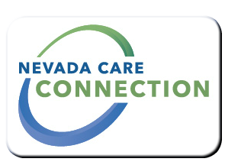
State of Nevada
Department of Health and Human Services
Director's Office
rt Division Here>

Consumer
FACT SHEET

OFFICE FOR CONSUMER HEALTH ASSISTANCE
Purpose
OCHA assists consumers with researching and resolving concerns related to access to health care and health insurance. This includes advocacy support with appeals/grievances, external review requests, billing, eligibility, benefits and/or claims denials. We can assist you with understanding your rights and responsibilities related to your health insurance plans. We also provide information to uninsured/underinsured Nevadans seeking insurance coverage, and prescription drug assistance resources. All services are provided absolutely free of charge.
Target Population
Nevadans seeking access to healthcare, insurance coverage, and prescription drug assistance or individuals with hospital/medical bill related issues

Eligibility
There are no eligibility requirements
Services

- Access to healthcare resources
- Appealing insurance denials
- Hospital and other medical bills
- Patient rights and responsibilities
- Prescription assistance resource
- Small business employer healthcare resource information
- Uninsured resources
- Workers compensation claim process, education, and guidance
Program Policies and Procedures
Seven to ten days after the case is submitted an ombudsman will contact client or will be contacted in order the case was received
How to Apply
To open a case call one of the numbers below:
For Information
Las Vegas  (702) 486-3587 | Toll Free  (888) 333-1597

Website
http://dhhs.nv.gov/Programs/CHA/

Last Updated: 3/8/16 JW

