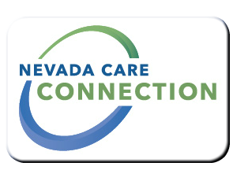
State of Nevada
Department of Health and Human Services
Division of Health Care Financing and Policy
rt Division Here>

Consumer
FACT SHEET

NEVADA MEDICAID - Durable Medical Equipment
Purpose
This is a service that is available through Nevada Medicaid. DMEPOS is serve recipients with medical need that can be met with medical equipment or supplies that are generally useful to a person in the absence of illness or injury and is appropriate for use in the home.
Target Population
Persons any age with a medical need for medical equipment or supplies.

Eligibility
Must be a Medicaid recipient with an illness or injury.
For more information on eligibility, visit: http://dhcfp.nv.gov/Resources/AdminSupport/Manuals/MSM/C1300/Chapter1300/
Services

- Standard medical equipment which can withstand repeated use and disposable medical supplies that meet the basic medical need of a recipient which generally is not useful to a person in the absence of illness or injury and is appropriate for use in the home
- Prosthetics and Orthotics
- Incontinence Supplies
- Mobility Devices
- Enteral and Parenteral foods
- Oxygen and oxygen supplies including CPAP and BiPAP items
Program Policies and Procedures
http://dhcfp.nv.gov/Resources/AdminSupport/Manuals/MSM/C1300/Chapter1300/
How to Apply
Apply for Medicaid at: http://dwss.nv.gov
For Information
Reno Medicaid District Office  775-687-1900 | Las Vegas Medicaid District Office  702-668-4200
All other Nevada Area Medicaid District Office  866-569-1746 | Central Medicaid District Office  1100 E. Williams St. Carson city, NV 89701  775-684-3600

Website
Division of Health Care Financing and Policy | http://dhcfp.nv.gov/Resources/AdminSupport/Manuals/MSM/C1300/Chapter1300/
Division of Welfare and Supportive Services | http://dwss.nv.gov
Hewlett Packard Enterprise Service (fiscal agent) for DHCFP | https://www.medicaid.nv.gov/Home.aspx

Last Updated: 3/29/16 JV

