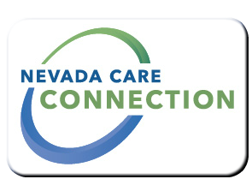
State of Nevada
Department of Health and Human Services
Division of Health Care Financing and Policy
rt Division Here>

Consumer
FACT SHEET

NEVADA MEDICAID - Adult Day Health Care
Purpose
Adult Day Health Care is a medical service that is provided to people in a community-based setting. Services include medical and social services that are delivered on a regular schedule to help people to stay living in their homes and out of an institution or nursing home.
Target Population
Adults 18 years and older.

Eligibility
Must be eligible for Nevada Medicaid and must meet eligibilty requirements based on an assesment and medical evaluation.
Services

- Nursing services for giving medications and medical treatments. Nurses may do assessments, plan care and provide direct supervision to meet a person's medical needs.
- Restorative therapy and training in Activities of Daily Living like bathing, dressing and grooming to help people maintain their highest level of functioning.
- Meals may be provided for part of the day. Nutritional assessment and planning may be included.
- Social and recreational activities to enhance a person's quality of life
- Transportation to and from the facility may be provided.
Program Policies and Procedures
Policies and procedure are outlined in Medicaid Services Manual Chapter 1800. http://dhcfp.nv.gov/Resources/AdminSupport/Manuals/MSM/C1800/Chapter1800
How to Apply
Applicants can locate any Adult Day Health Care facility to begin the application process.
For Information
Divison of Health Care Financing and Policy (Nevada Medicaid)  Carson City  1100 E. William Street, Carson City, NV 89701  (775) 684-3600 | Las Vegas  1210 So. Valley View Blvd Suite #104, Las Vegas, NV 89102  (702) 668-4200

Website
Division of Health Care Financing and Policy - Nevada Medicaid: | www.dhcfp.nv.gov

Last Updated: 6/7/16 GB

