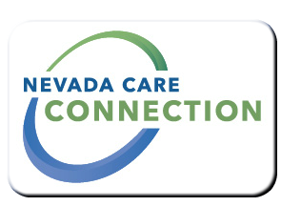
State of Nevada
Department of Health and Human Services
Division of Health Care Financing and Policy
rt Division Here>

Consumer
FACT SHEET

INDIAN HEALTH PROGRAM
Purpose
The Indian Health Programs promote the health care of American Indians and Alaska Natives in the State of Nevada through tribes, tribal organizations and urban Indian organizations.
Target Population
Members of an Indian tribe as defined in title IV of the Indian Health Care Improvement Act

Eligibility
Must be a Medicaid recipient; must be Indian and/or Alaska Native descent; must be a member of a tribe, band, or other organized group or community of Indians.
For information visit: http://dhcfp.nv.gov/Pgms/CPT/IHP/
Services

- Medically necessary services provided by an Indian Health Services Clinic or Tribal Health Clinic (not all inclusive): Physician Services; Early and Periodic Screening, Diagnostic and Treatment; Inpatient and Outpatient Services; Lab and x-ray; Family Planning; Clinic Services; Dental Services; Physical, Occupational, Speech Therapy; Pharmacy; Behavior Health Services; Audiology Services; and Ocular Services.
Program Policies and Procedures
Medicaid Services Manual Chapter 3000, Indian Health Programs: http://dhcfp.nv.gov/Resources/AdminSupport/Manuals/MSM/C3000/Chapter3000/
How to Apply
Apply for Medicaid at: https://dwss.nv.gov/
For Information
Contact your local Medicaid office:  Reno  560 Hammill Way, Reno, NV 89511  (775) 687-1900 | Las Vegas  1210 S. Valley View, Suite 104, Las Vegas, NV 89102  (702) 668-4200
Carson City  1100 East William Street, Suite 101, Carson City, NV 89701  (775) 684-3676 | Elko  1010 Ruby Vista Drive, Suite 103, Elko, NV 89801  (775) 753-1191

Website
http://dhcfp.nv.gov/Pgms/CPT/IHP/ | https://www.ihs.gov/phoenix/

Last Updated: 3/22/16 SS

