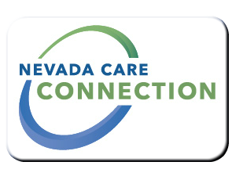
State of Nevada
Department of Health and Human Services
Aging and Disability Services Division
rt Division Here>

Consumer
FACT SHEET

HOMEMAKER PROGRAM
Purpose
Homemaker services enable those with a disability or frail elderly Nevadans to remain in their homes by providing homemakers, who can assist with basic homecare tasks. These services help to preserve or improve the quality of the recipients' lives and reduce the need for unnecessary out-of-home placements
Target Population
Adult with a disability determination or over the age of 60.

Eligibility
Must be adult with a disability determination or over the age of 60; functional deficit causing inability to complete homemaker tasks; subject to asset limitations, subject to income limitations.
See website for income and asset information at http://adsd.nv.gov
Services

- Assistance with light housekeeping, meal preparation, laundry and essential shopping. Services are limited to 1 hour and 45 minutes weekly.
- Case Management: Licensed social workers make quarterly contact with clients to assess their services and determine that services are maintaining client's living area/residence.
Program Policies and Procedures

How to Apply
Contact your local Aging and Disability Services Division office.
For Information
Carson City Office:  3416 Goni Rd, Suite D-132, Carson City, NV 89706  (775) 687-4210 | Las Vegas Office:  1860 East Sahara Ave, Las Vegas, NV 89104  (702) 486-3545
Reno Office:  9670 Gateway Drive, Suite 200, Reno, NV 89521  (775) 688-2964 | Elko Office:  1010 Ruby Vista Dr, Suite 104, Elko, NV 89801  (775) 738-1966

Website
http://adsd.nv.gov

Last Updated: 5/27/16 EK

