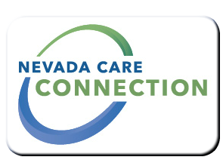
State of Nevada
Department of Health and Human Services
Division of Health Care Financing and Policy
rt Division Here>

Consumer
FACT SHEET

Facility Outreach and Community Integration Services (FOCIS)
Purpose
Is a Medicaid program that offers a voluntary service intended to provide Medicaid recipients with a choice to seek an alternative to institutional placement. The FOCIS Health Care Coordinator role is to assess recipient's needs to access appropriate Medicaid services and community resources as a means to live outside of a medical institution. FOCIS can assist any Nevada Medicaid recipient at risk of admission to a long term care facility, pending discharge from a greneral hospital, acute rehabilitation hospital, other institution or currently residing in a nursing facility.
Target Population
Medicaid recipients who are at risk or reside in an institution. No age restriction.

Eligibility
Medicaid eligible
Services

- Care Coordination: Is offered by social workers, nurses, and other professional staff identified as Health Care Coordinators that performs a service of linking individuals who have complex needs with appropriate services, to include assessments, care planning, resources and referral, case monitoring, and follow-up that allow recipients to live in the least restrictive environment.
- FOCIS' Health Care Coordinators advocate for recipients by:
  - Working together with the recipient, legal guardian, facility staff, and others requested by the recipient,
  - Providing information on available services,
  - Assist with applications, and
  - Identify and mitigate risk.
Program Policies and Procedures

How to Apply
To apply directly to the program complete the FOCIS Referral Form from the website and either fax or mail to the correct office listed on the form.
For Information
For more information, contact one of the Nevada’s FOCIS units:
FOCIS in the Las Vegas Area  (702) 668-4200 | FOCIS in the Carson City Area  (775) 684-3651
FOCIS in the Reno Area  (775) 687-1900 | FOCIS in the Elko Area  (775)753-1191

Website

Last Updated: 6/17/16 PS

