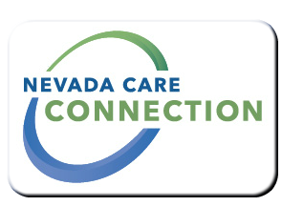
State of Nevada
Department of Health and Human Services
Division of Welfare and Supportive Services
rt Division Here>

Consumer
FACT SHEET

ENERGY ASSISTANCE PROGRAM
Purpose
To assist qualifying low income Nevadans with the cost of home energy
Target Population
Qualifying low income Nevadans

Eligibility
Must be able to provide documents verifying the following: citizen criteria; Nevada residency; household composition, income of all household members, energy usage (utility bill), and that the household is responsible, at least partially, for in home heating or cooling costs.
Services

- Provides qualifying low-income households with an annual benefit to assist in meeting their household's energy needs. The amount of the benefit is based on the family's income, size and energy usage. In most cases the benefit is sent directly to their utility vendor/s and appears as a deposit on their account. Payments may be provided directly to the household if they are reliant on wood, pellets, propane, heating oil, etc. to meet their home heating needs.
Program Policies and Procedures
The EAP program year operates year round. Qualifying household are eligible for assistance once each state fiscal year.
How to Apply
Applications are available through the Division of Welfare and Supportive Services (DWSS) web site, all DWSS offices, over 50 contracted Intake Sites statewide, or by calling the Customer Service Unit. Complete applications may be mailed, faxed or dropped off at one of the following locations or submitted through an Intake Site. A listing of current Intake Sites is available on our website.
For Information
Contact your local office:  Las Vegas/North Las Vegas  3330 E. Flamingo Rd #55, Las Vegas, NV 89121  (702) 486-1404 | All Other Areas  2527 N. Carson Street, Suite 260, Carson City, NV 89706  (775) 684-0730
Las Vegas/North Las Vegas Fax  (702) 486-1441 | All Other Areas Fax  (775) 684-0740

Website
https://dwss.nv.gov/

Last Updated: 3/8/17 LW

