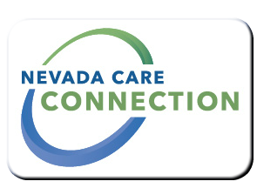
State of Nevada
Department of Health and Human Services
Aging and Disability Services Division
rt Division Here>

Consumer
FACT SHEET

DISIBILITY Rx/SENIOR Rx
Purpose
Providing disabled and senior Nevadans relief from the high cost of prescription medication
Target Population
Seniors in need of assistance with prescription medication; Disabled individuals in need of assistance with prescription medication

Eligibility
Seniors eligible for Medicare Part D; disabled persons 18-61 collecting Social Security Disability and are Medicare eligible; twelve months continuous Nevada residency; income limits apply
For details: http://adsd.nv.gov/Programs/ADSD_Programs/
Services

- Help with monthly premiums for Medicare Part D Prescription Drug Plan
- Help with prescription costs after reaching the Medicare Part D coverage gap
Program Policies and Procedures
For an application call: (775) 687-0539 if calling from Reno, Carson City or Gardnerville areas; If calling outside these areas call toll-free 1-866-303-6323 Option 7;
How to Apply
For application: inquire online at the website listed below. This online application can be printed out and mailed or faxed to (775 )687-0576
For Information
Aging and Disability Services Division Admin. Office  3416 Goni Rd, Suite D-132, Carson City, NV 89706  (775) 687-4210 | Disability RX/Senior RX Info  (775) 687-0539  (866) 303-6323

Website
Nevada Senior RX | http://adsd.nv.gov/Programs/Seniors/SeniorRx/SrRxProg/
Nevada Disability RX | http://adsd.nv.gov/Programs/Physical/DisabilityRx/DisabilityRx/

Last Updated: 5/23/16 LJ

