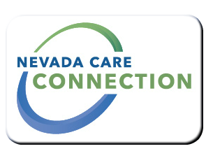
State of Nevada
Department of Health and Human Services
Division of Welfare and Supportive Services
rt Division Here>

Consumer
FACT SHEET

CHILD CARE AND DEVELOPMENT PROGRAM
Purpose
The Child Care and Development Program subsidizes child care services for qualified low income families and provides quality improvement activities for the early childhood system in Nevada.
Target Population
Low income working parents with children under 13 years of age.

Eligibility
Parents have to be in a TANF/NEON activity, or working and under 130 of Federal Poverty Level (FPL)
Eligibility Information: https://dwss.nv.gov/
Services

- Child care subsidies
- Child Care Resource and Referral: Help parents find child care services that meet their family's needs
Program Policies and Procedures

How to Apply
http://www.childrenscabinet.org/child-care-resources/for-parents/help-paying-for-child-care/ or http://lvul.org/early-childhood-connection/
For Information
Children's Cabinet (northern and rural Nevada)  (775) 856-6200 | Las Vegas Urban League (southern Nevada)  (702) 473-9400

Website
http://www.childrenscabinet.org/child-care-resources/for-parents/help-paying-for-child-care/ | or http://lvul.org/early-childhood-connection/

Last Updated: 4/1/16 JZ

