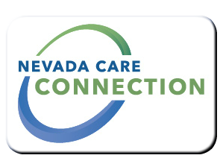
State of Nevada
Department of Health and Human Services
Aging and Disability Services Division
rt Division Here>

Consumer
FACT SHEET

AUTISM TREATMENT ASSISTANCE PROGRAM (ATAP)
Purpose
To assist parents and caregivers with the costs of providing Autism-specific treatments to children with Autism Spectrum Disorder
Target Population
Individuals who are Nevada residence under the age of 19 and have a diagnosis or determination of an Autism Spectrum Disorder by a physician, psychologist, pediatric neurologist or other qualified professionals.

Eligibility
Children from 18 months to 19 years of age; Children diagnosed with Autism, Asperger’s Syndrome, PDD-NOS, Pervasive Developmental Disorders Not Specified.
Services

- Uses Applied Behavior Analysis techniques to develop useful behaviors and to reduce behaviors that may be harmful or interfere with learning.
- The ATAP program uses a Supervision Tier Structure designed to protect the child’s budget by limiting what providers can charge and ensure basic level of treatment supervision is received and expected on a monthly basis.
- There are multiple ATAP plan types; they are selected during an assessment between an ATAP care manager, provider and parent. These plans are designed to address every child’s needs based on hours received.
- Speech, Occupational and Physical therapy are also available.
Program Policies and Procedures

How to Apply
Initial application/inquiry – 775-687-4210 (English/Spanish)
For Information
Carson City Administrative Office- ATAP Program
(775) 687-4210
Website
Website: | http://adsd.nv.gov/Programs/Autism/ATAP/ATAP/
Brochure: | http://adsd.nv.gov/uploadedFiles/adsdnvgov/content/Programs/Autism/ATAP/ATAP_Brochure.pdf

Last updated: 4/12/16 BA

